1. **<Staff> Training machine Use Case Diagram**
   1. **<Staff> Merge Products Use Case Diagram**

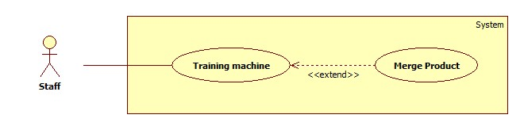

|  |  |  |  |
| --- | --- | --- | --- |
| **USE CASE – SB013** | | | |
| **Use Case No.** | SB01 | **Use Case Version** | 2.0 |
| **Use Case Name** | Merge products | | |
| **Author** | Dang Huu Hoang | | |
| **Date** | 20/02/2014 | **Priority** | High |
| **Actor:**   * Staff   **Summary:**   * This use case allows staff to process product name maybe duplicate.   **Goal:**   * Training machine to merge product name which maybe duplicate.   **Triggers:**   * Staff wants to merge product name which maybe duplicate by training machine. * To training machine, staff must do the following steps:   + Click “Xử lý sản phẩm trùng” menu.   + Select products and click “Gộp” button   **Preconditions:**   * User must log in the system with staff role. * Staff saved log file when import excel.   **Post Conditions:**   * **Success**: Products will be saved to the database. Show success message. * **Fail:** Nothing is saved to the database. Show error message.   **Main Success Scenario:**   |  |  |  | | --- | --- | --- | | Step | Actor Action | System Response | | 1 | From the staff’s page, staff clicks “Xử lý sản phẩm trùng” link. | System will get log file and show “Xử lý sản phẩm trùng” page with tables has 3 columns:   * Checkbox. * Tên sản phẩm label. * Radio button   [Alternative 1] | | 2 | Staff selects products on checkbox and select main product on radio button to merge, then click “Gộp” button. | * System will save checked products with product id equals product id of main product. * System will show a message: “Gộp thành công”.   [Alternative 2] [Exceptions 1] |   **Alternative Scenario:**   |  |  |  | | --- | --- | --- | | Step | Actor Action | System Response | | 1 | Log file is empty. | System will show a message: “Chưa có dữ liệu”. | | 2 | Staff selects products on checkbox and select main product on radio button to merge, then click “Gộp” button. | * If product does not exist in the database, add new dictionary. * System will show a message: “Gộp thành công”.   [Exceptions 1] |   **Exceptions:**   |  |  |  | | --- | --- | --- | | Step | Actor Action | System Response | | 1 | Fail to insert or update to database. | Display error message: “Có lỗi xảy ra. Vui lòng thử lại sau”. |   **Relationships:** Import excel.  **Business Rules:**   * Valid file format :      * Log file is notepad (.txt) | | | |

* 1. **<Staff> Split Products Use Case Diagram**

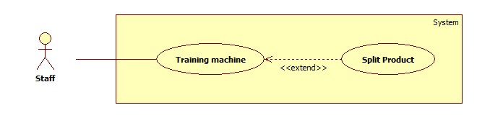

|  |  |  |  |
| --- | --- | --- | --- |
| **USE CASE – SB013** | | | |
| **Use Case No.** | SB01 | **Use Case Version** | 2.0 |
| **Use Case Name** | Split products | | |
| **Author** | Dang Huu Hoang | | |
| **Date** | 20/02/2014 | **Priority** | High |
| **Actor:**   * Staff   **Summary:**   * This use case allows staff to process product name maybe duplicate.   **Goal:**   * Training machine to split product name which maybe duplicate.   **Triggers:**   * Staff wants to split product name which maybe duplicate by training machine. * To training machine, staff must do the following steps:   + Click “Xử lý sản phẩm trùng” menu.   + Select products and click “Tách” button   **Preconditions:**   * User must log in the system with staff role. * Staff saved log file when import excel.   **Post Conditions:**   * **Success**: Products will be saved to the database. Show success message. * **Fail:** Nothing is saved to the database. Show error message.   **Main Success Scenario:**   |  |  |  | | --- | --- | --- | | Step | Actor Action | System Response | | 1 | From the staff’s page, staff clicks “Xử lý sản phẩm trùng” link. | System will get log file and show “Xử lý sản phẩm trùng” page with tables has 3 columns:   * Checkbox. * Tên sản phẩm label. * Radio button   [Alternative 1] | | 2 | Staff selects products on checkbox to split, then click “Tách” button. | * System will add new product to database. * System will show a message: “Gộp thành công”.   [Alternative 2] [Exceptions 1] |   **Alternative Scenario:**   |  |  |  | | --- | --- | --- | | Step | Actor Action | System Response | | 1 | Log file is empty. | System will show a message: “Chưa có dữ liệu”. | | 2 | Staff selects products on checkbox to split, then click “Tách” button. | If product is already in the database, update its information. [Exceptions 1] |   **Exceptions:**   |  |  |  | | --- | --- | --- | | Step | Actor Action | System Response | | 1 | Fail to insert or update to database. | Display error message: “Có lỗi xảy ra. Vui lòng thử lại sau”. |   **Relationships:** Import excel.  **Business Rules:**   * Valid file format :      * Log file is notepad (.txt) | | | |

1. **Sequence diagram**
   1. **Merge product Sequence Diagram**

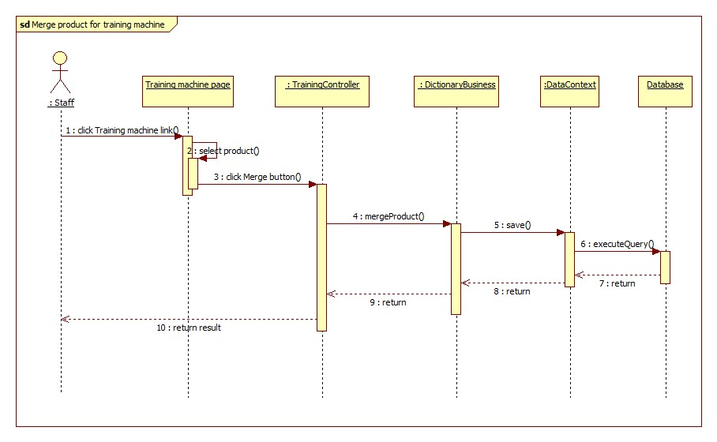

* 1. **Split product Sequence Diagram**

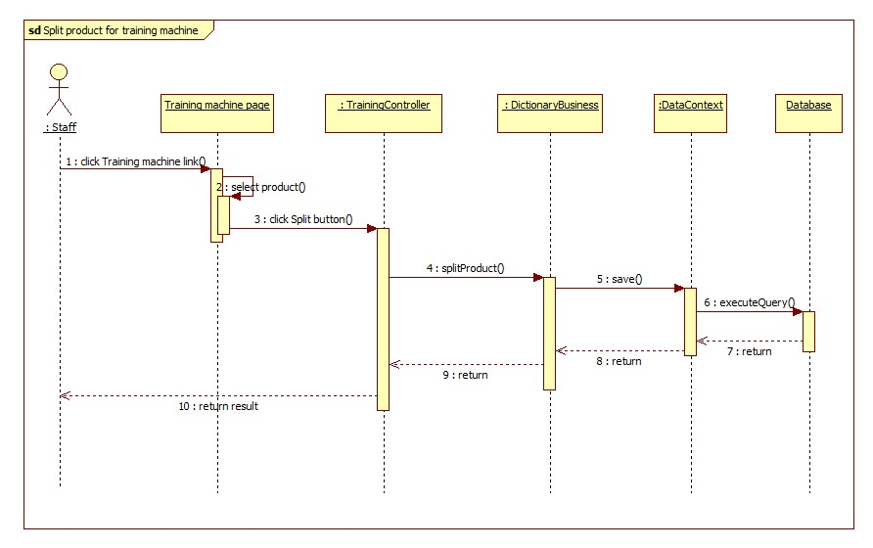

**Mobile architecture**

